About the Marie Tremaine Fellowship and Eligibility
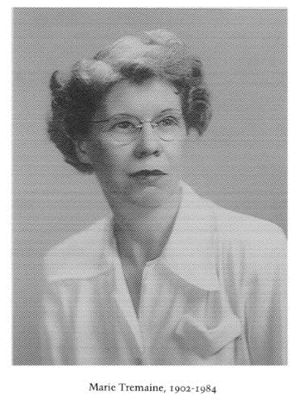
The Marie Tremaine Fellowship is offered in memory and through the generosity of Marie Tremaine (1902-1984), the doyenne of Canadian bibliographers. Dr. Tremaine was an outstanding scholar of early Canadiana, whose publications on bibliography and history of printing in Canada are considered foundational. The Fellowship was instituted in 1987 and is offered annually to support the work of a scholar engaged in some area of bibliographical research, including textual studies and publishing history and with a particular emphasis on Canada.
The amount of the Fellowship is $2,000.00. The recipient of the Fellowship also receives a free one-year membership in the Bibliographical Society of Canada.
The Fellowship will be awarded only in support of specific research projects involving discrete areas of research. Projects that are part of some larger undertaking will not be considered unless they can be completed on their own, and can lead to findings that are reportable or publishable in themselves.
All scholars may apply, except the members of the Bibliographical Society of Canada Executive and Awards and Fellowships Committees.
The funds available are for out-of-pocket expenses such as travel fares and subsistence, and technical services or supplies, and may not be used for salaries or stipends.
See http://www.bsc-sbc.ca/en/fellowship-awards/recipients-of-the-marie-tremaine-fellowship/ for a list of past recipients and their projects.
Application Deadline and Process
The completed application should be sent to fellowships_bourses@bsc-sbc.ca no later than 20 January 2025. Electronic applications are preferred. If submitting electronically is not possible, a hard copy of the completed application must be received by the Chair of the Committee by January 20, 2025, at the following address:
Heather Dean
Chair, Fellowships Committee, Bibliographical Society of Canada
Special Collections and University Archives
University of Victoria Libraries
PO Box 1800 STN CSC
Victoria, BC V8W 3H5

About the Bibliographical Society of Canada
The Bibliographical Society of Canada, established in 1946, aims to promote bibliographical publications; to encourage the preservation of and to extend knowledge about printed works and manuscripts, particularly those relating to Canada; to facilitate the exchange of information concerning rare Canadiana; to coordinate bibliographical activity, and to set standards.

Applicant Information

Name
Email address
Telephone number
Postal address
Institutional Affiliation
(if none, indicate “Independent Scholar”)
Current position

Education and degree(s) obtained – include years and institutions where degrees were earned
Discipline

Significant Publications
Relevant Experience

Project Information
Project information can be pasted below into each section. Please observe specified word limits.
Title of Project:

Summary of Project: Provide a summary of your project that can be used for the announcement of the award. (500 words maximum)

Description of Project: Please provide a description which includes objectives, significance, organization, and methods employed in your project, as well as work completed, in progress, and to be undertaken. You may wish to provide brief samples of your work. Total word count for description and samples should not exceed 1000 words.

Budget: Include specific information regarding costs, including economy travel fares, mileage, duration of travel, accommodation, daily expenses, and technical services or supplies associated with the undertaking of this project. The budget should not exceed $2000 CAD. Itemize expenses below. Indicate any other support, either granted or requested for this project.

References: Please provide the names, email addresses, and phone numbers of two persons who could write a reference letter on your behalf. Referees are not required to submit a letter for the 20 January deadline but might be contacted at a later date to provide further comments on the application.

1.

2.

Applicant’s signature Date:
___________________________________________ ______________________________

